# Create a Subaccount to use SAP Build Services

You can find details about the services offered in SAP BTP at discovery-center.cloud.sap.

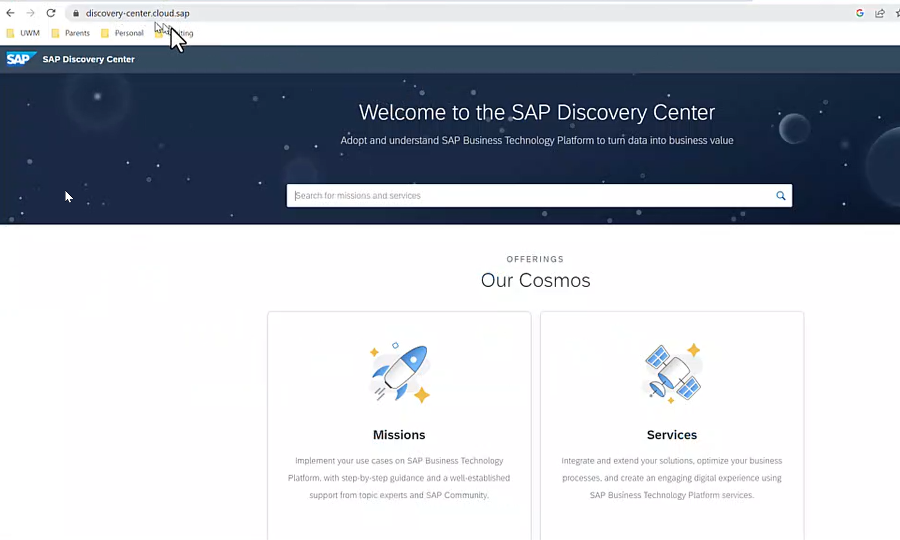

Click on Services.

You can search for SAP Build Apps. You can see on the tile that this service is available on the free tier of BTP.

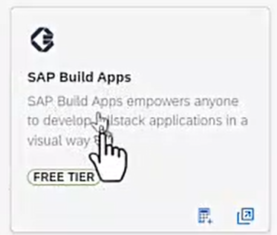

On the Pricing tab, you can see which region hosts the service. You should choose one close to your location.

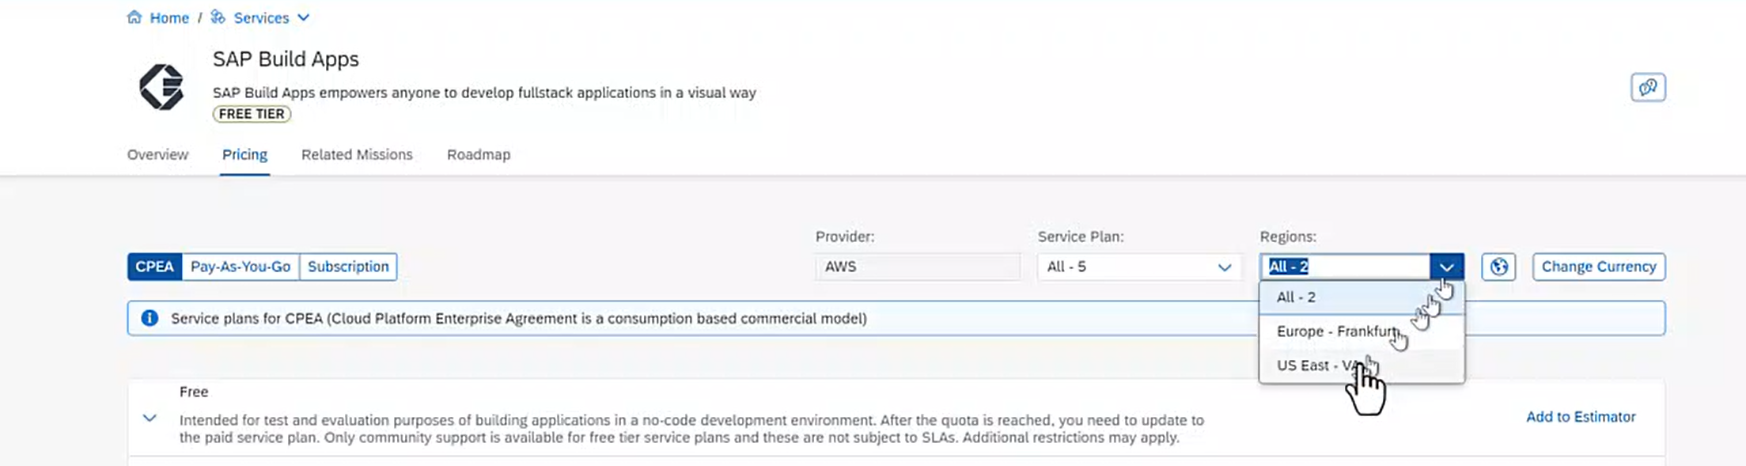

BTP is organized into layers. The top layer is your Global account and is used to manage which entitlements you have access to, billing, etc. Work is done in Subaccounts, so before you can create an app in SAP Build Apps, you have to create a Subaccount that has that service installed.

In this case, you will create a Subaccount manually. From the global level of your BTP account, click the Subaccounts tab then click Create – Subaccount. You can also create Directories so you can organize your subaccounts.

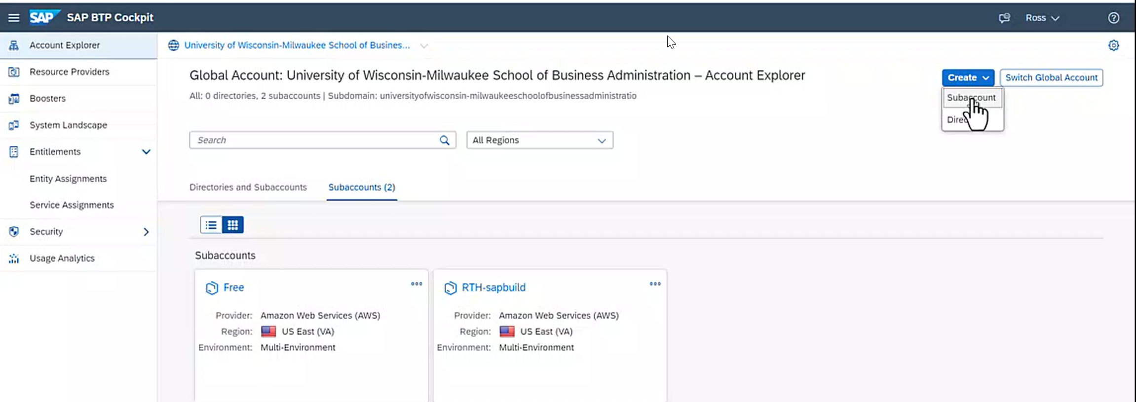

Enter a Display Name, Subdomain and select the region. You can use the same name for the Display name and Subdomain. Click Create.

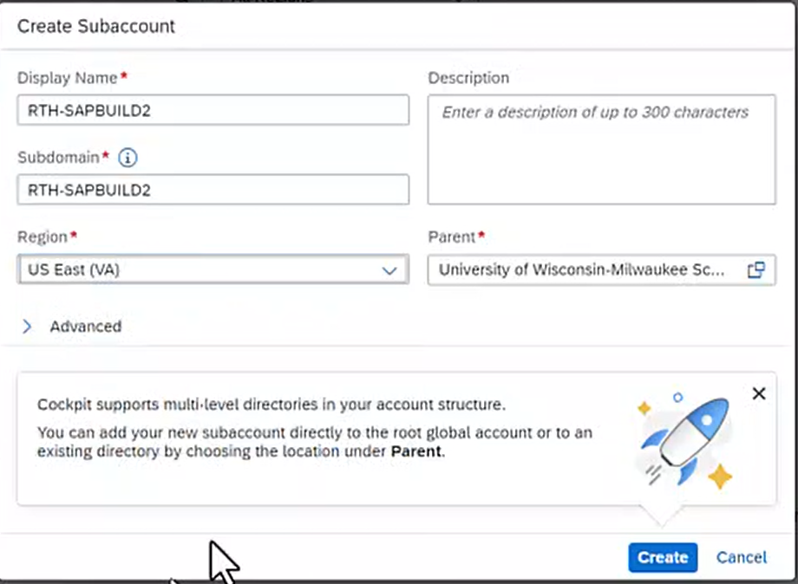

Once the Subaccount is created, it will appear in the Subaccounts tab. Click to enter it.

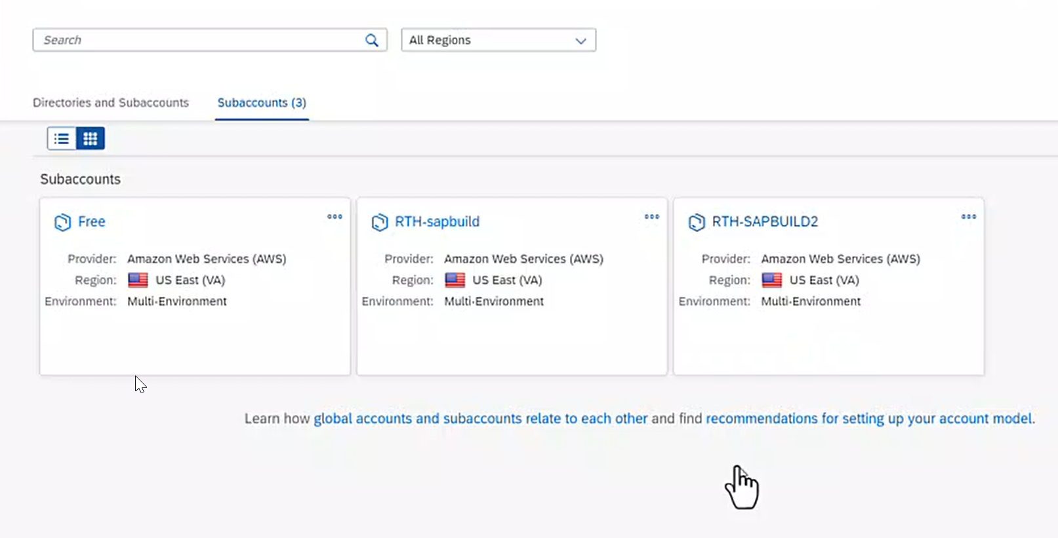

Inside the Subaccount, click Entitlements. This shows the services available in the subaccount. Make sure Cloud Identity Services appears on the list. This is required to access SAP Build Apps.

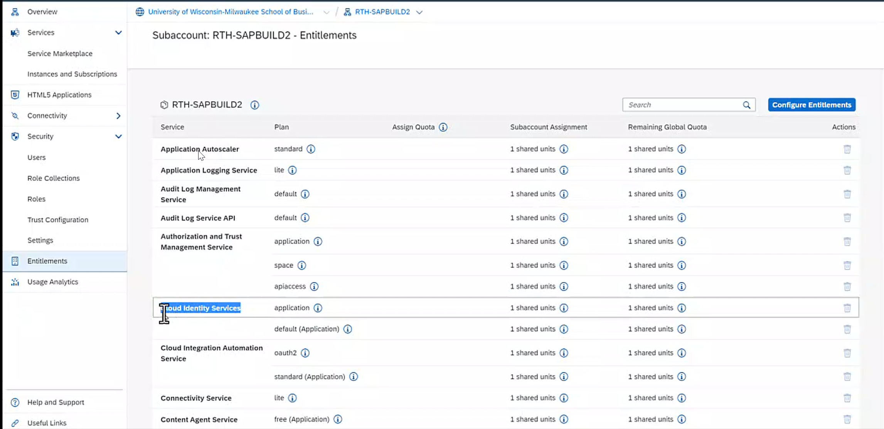

The next step is to install the SAP Build Apps subscription in the subaccount. Go back to the Global account level using the breadcrumbs at the top of the screen. Click on Booster. Boosters are wizards that manage complex configurations.

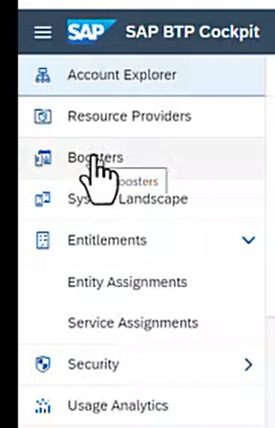

Search for SAP Build and look for the Get started with SAP Build Apps tile.

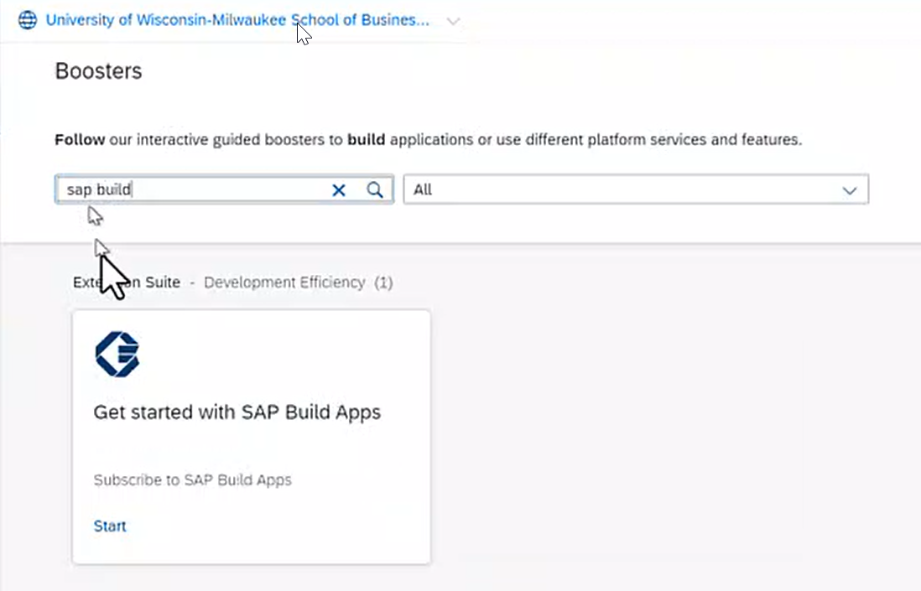

Click Start.

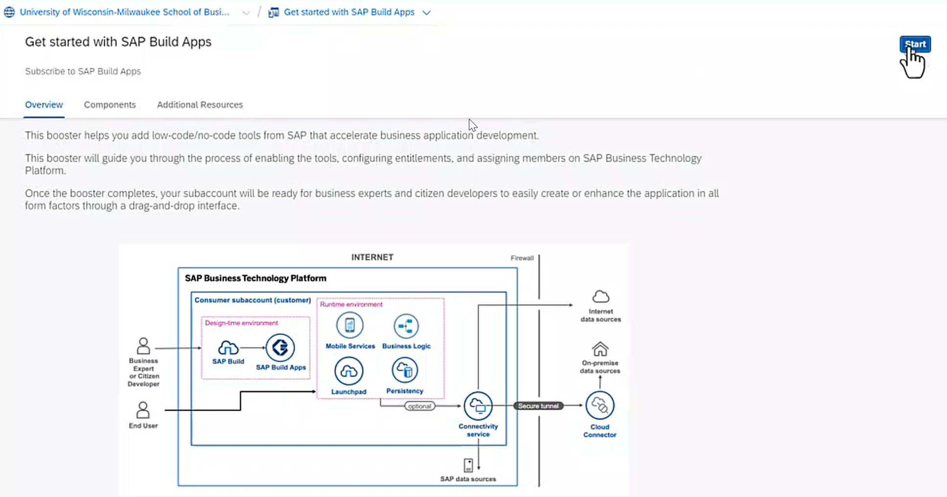

In the first step SAP BTP checks the prerequisites. They should turn green.

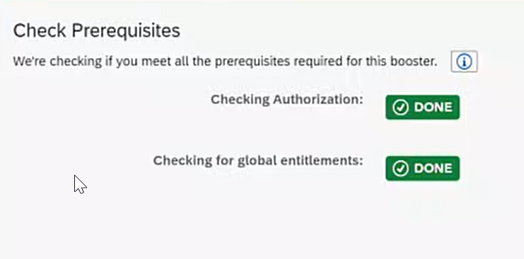

Select the Subaccount, enter an Org and click Next.

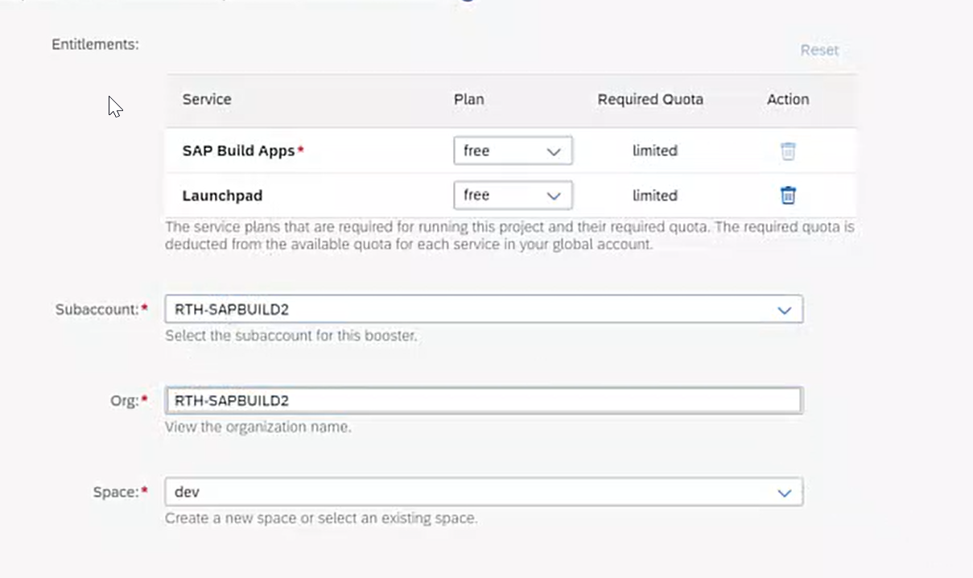

The booster creates an Administrator and Developer account for the email address you logged into the global account with. You can add additional emails to create other accounts, or you can leave these blank. Click Next.

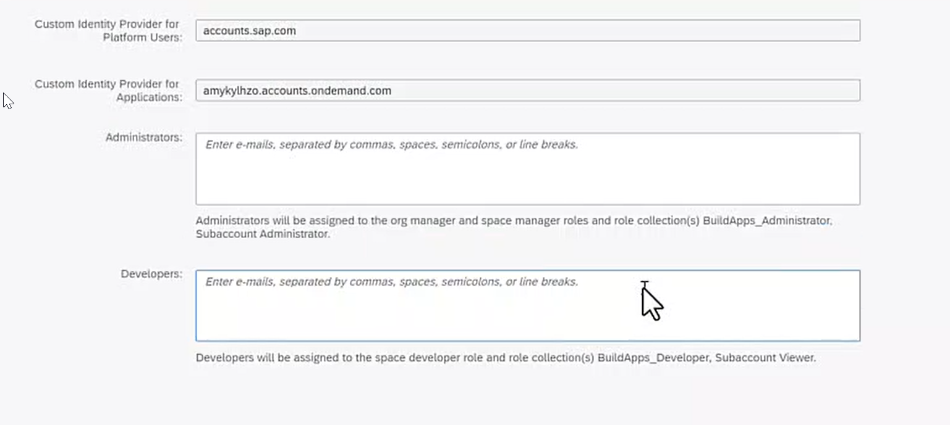

The next screen summarizes the information you entered. If it looks good, click Finish. The Booster will configure the services.

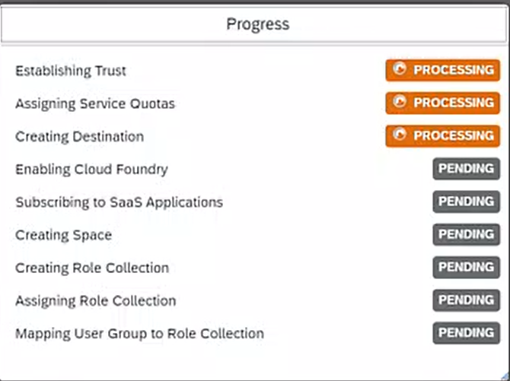

When it finishes, you can click Navigate to Subaccount in the dialog or return to your Global account and click the new Subaccount tile.

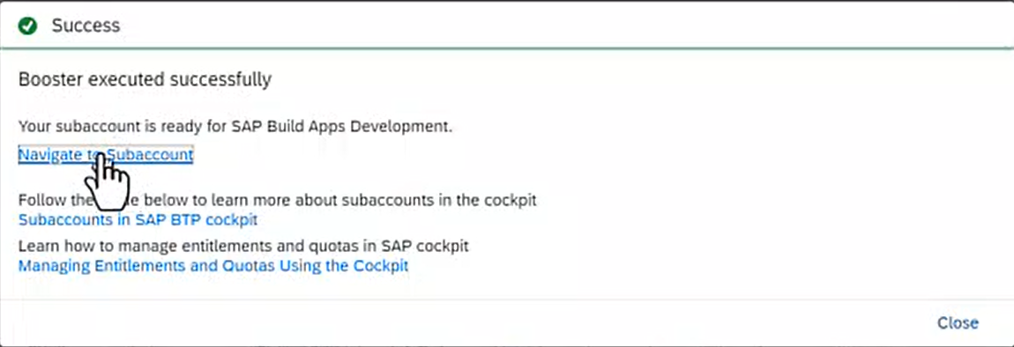

In Security – Role Collections, you will see the authorizations created to allow your user to access SAP Build Apps.

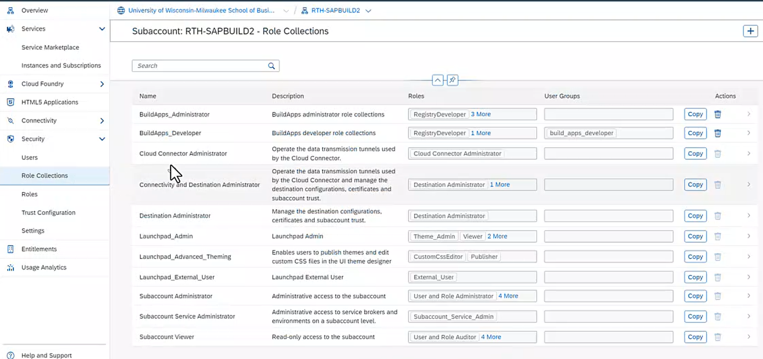

On the Security – Users page, you can see the Booster created the user you use to access SAP Build Apps. If you select the user that authenticates with the Custom IAS identity service, you can see it has been assigned the role collections it needs.

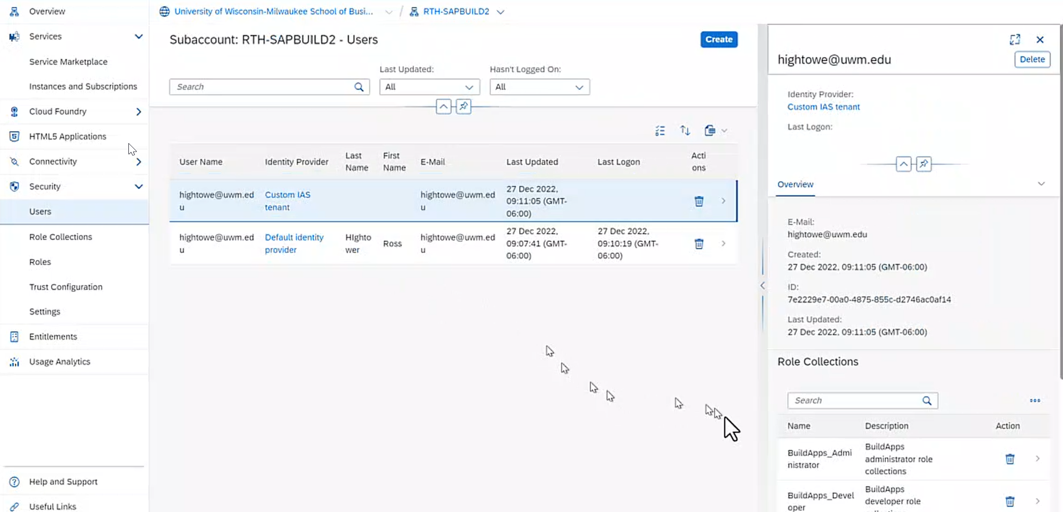

On the Security – Trust Configuration page you can see that the Custom IAS identify service is set as the default.

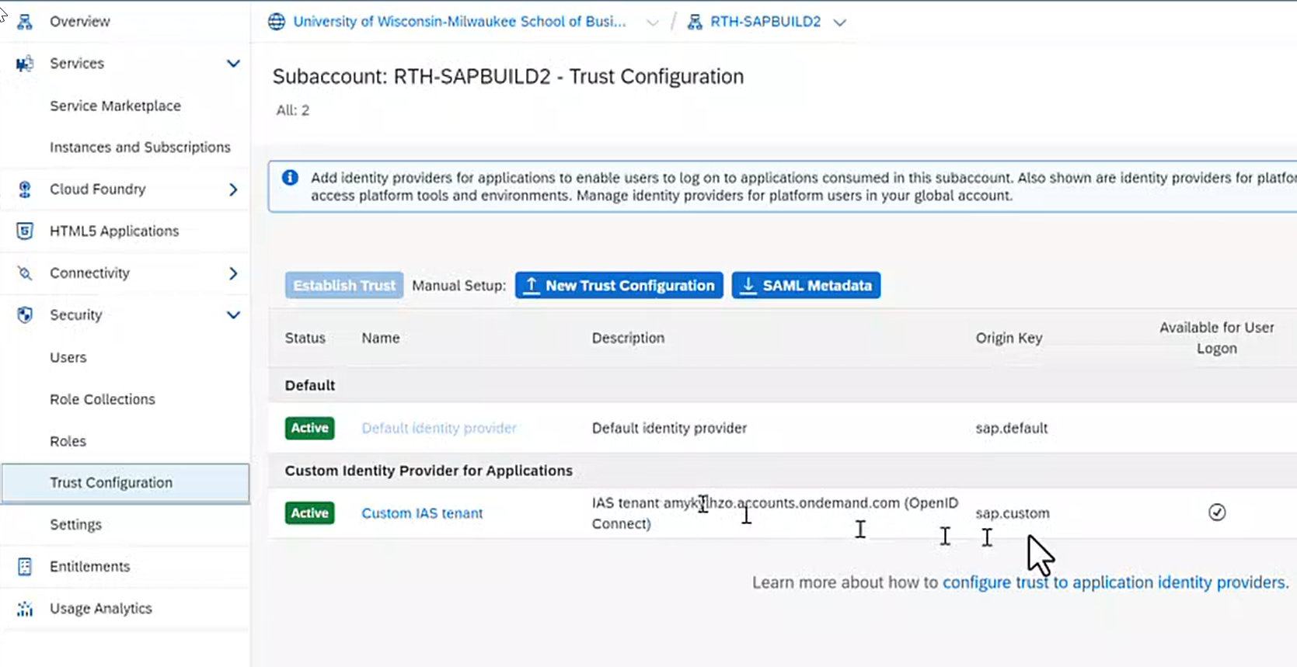

The subaccount is now ready.